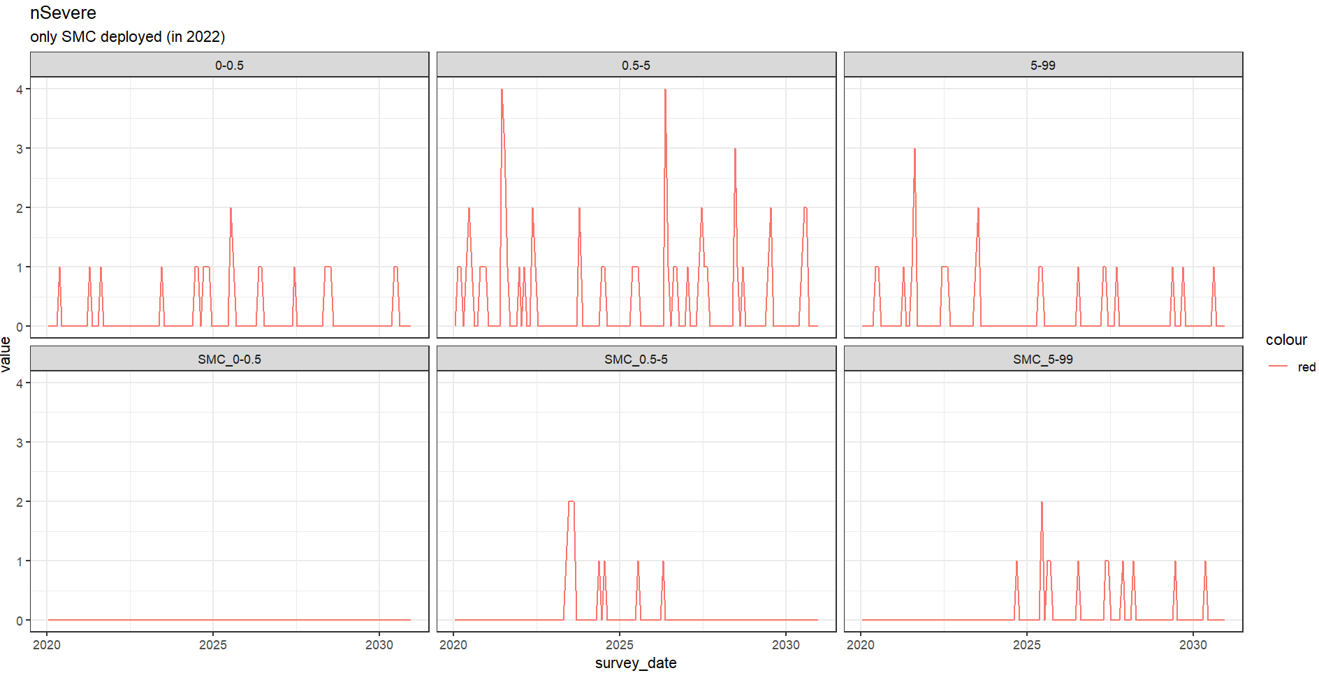
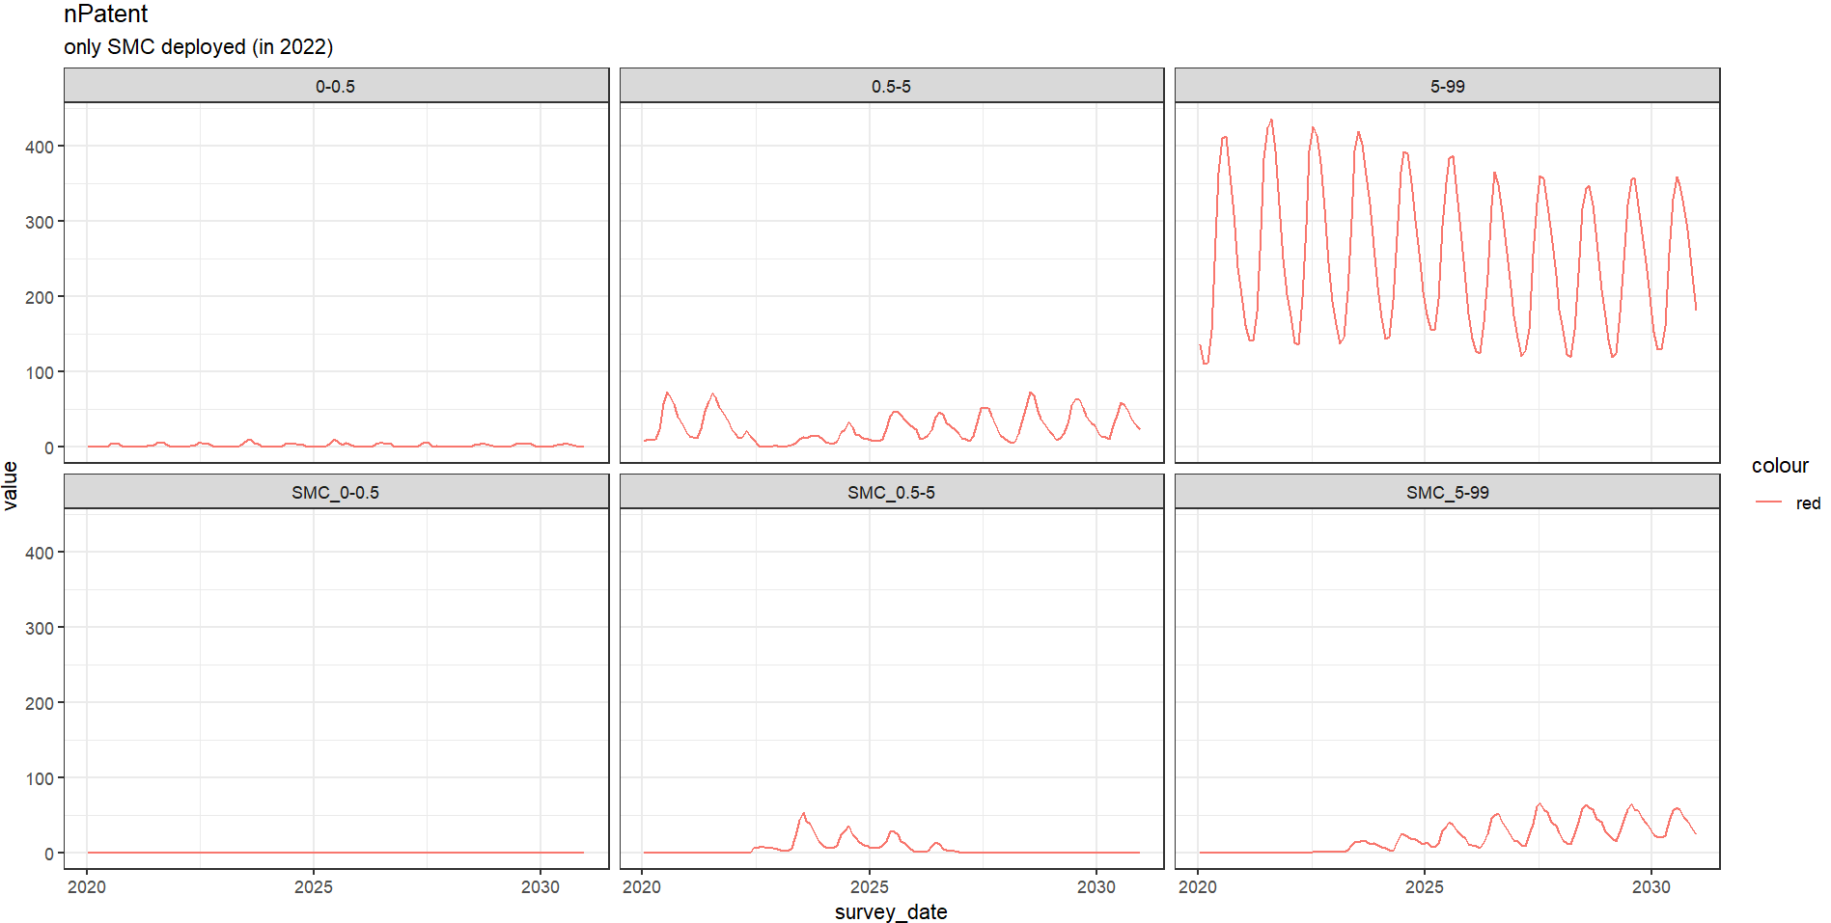
TRIAL – retrain GPs with a seq of future coverage levels for all four interventions and ntreat1 + ntreat2 or nSevere as outcome
- Say we have 5 diff levels of coverage of SMC
- Age cohorts with and without SMC
- How does the number of uncomplicated cases evolve in both cohorts
- Eg: If we have 100 percent SMC cov for 0.5-5, then we know that all those outside this grp did not receive SMC so we can look at those for community protection
- But if we have 80p SMC, then we look at the 20p within the age cohort and also outside the cohort
- Ask Roland to help write cohort into the baselist in the script?
COMMUNITY EFFECT PAPER ( Unraveling the ‘community effects’ of
interventions against malaria
endemicity: a systematic scoping review – Ko et al.)
- Indirect effects can be defined as the unintended positive or negative consequences of an intervention that influences disease transmission or health outcomes.
- malaria control measures implemented in a community are expected to yield direct benefits for individuals receiving the interventions and indirect benefits for both individuals receiving and not receiving the interventions.
- without proper consideration of the indirect effects, malaria interventions’ impacts on health outcomes and their cost-effectiveness may be overestimated or underestimated.
- evidence of indirect effects will influence policymakers’ decisions.
- Adopting a comprehensive and standardised approach to identify both direct and indirect effects is imperative to gain a detailed understanding of intervention impacts
- If the direct effects are equivalent, an intervention that broadly benefits those who do not receive the intervention is preferable to one that benefits only a limited number of people who receive the intervention
- They defined indirect effects as the impact accrued by either the non-intervention or intervention group in addition to the direct effects of the intervention

Indirect effect analysis methods
- comparison between non-treatment recipients in the treatment community and the control group
  - pre-post comparisons among non-recipients
- Comparison conditional on treatment coverage or geographical distance
- comparisons within the treatment area according to
- the coverage, including both those who received treatment and those who did not

Among nine studies employing mathematical models, two-thirds (n=6) aimed to estimate the indirect effects of ITNs/LLINs, comparing outcomes before and after the intervention in the non-intervention group or altering parameters of intervention coverage through simulation

Unwin et al (2023) disentangled the direct and indirect effects of ITNs by comparing fixed entomological inoculation rates (EIR) over time in a counterfactual scenario with the reduction in EIR caused by a decrease in infected individuals and mosquitoes

How can you use indirect protection as a means of deprioritization.
Where should we deprioritize smc by using the indirect protection of llin
This is something you will have a hard time measuring in an RCT so we are using a transmission model to inform
Decreasing equals saturation effect
Increasing equals indirect protection
Regression methods to analyse the curves
Say smc is abt 80% then we would calculate Y / N
When the number for the llin cov is less than smc then we say llin can be a viable alternative to smc or supplementing with smc is not cost effective because you could achieve the same effect with llins

